EXP 8

age=factor(c(23,43,23,26,57,23,43,23,26,57))

plot(age,col="yellow",xlab="pandas",ylab="Loki")

###############

lomo=c(1:10)

plot(lomo,col="blue",xlab="pandas",ylab="Loki")

##############################

par(mfrow=c(1,2))

**OUTPUT**

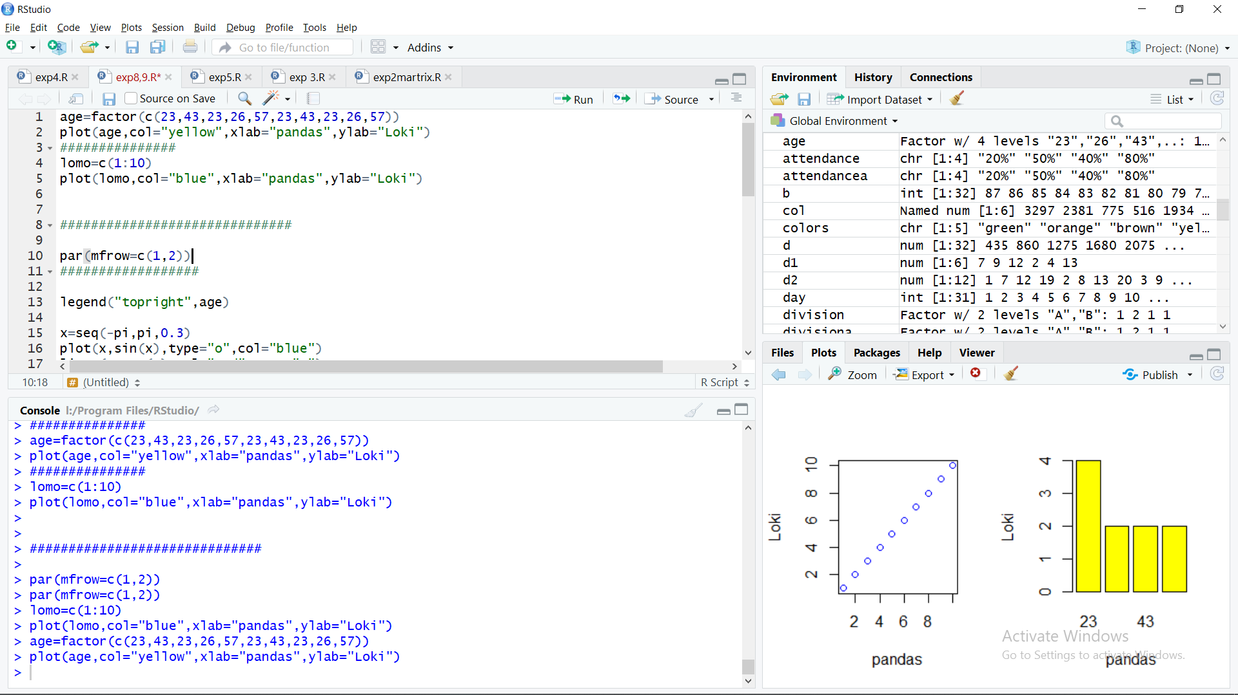

##################

legend("topright",age)

x=seq(-pi,pi,0.3)

plot(x,sin(x),type="o",col="blue")

lines(x,cos(x),col="red",type="o")

legend("topleft",cex=0.4,legend=c("sin(x)","cos(x)"),title="Indicators",fill=c("blue","yellow"))

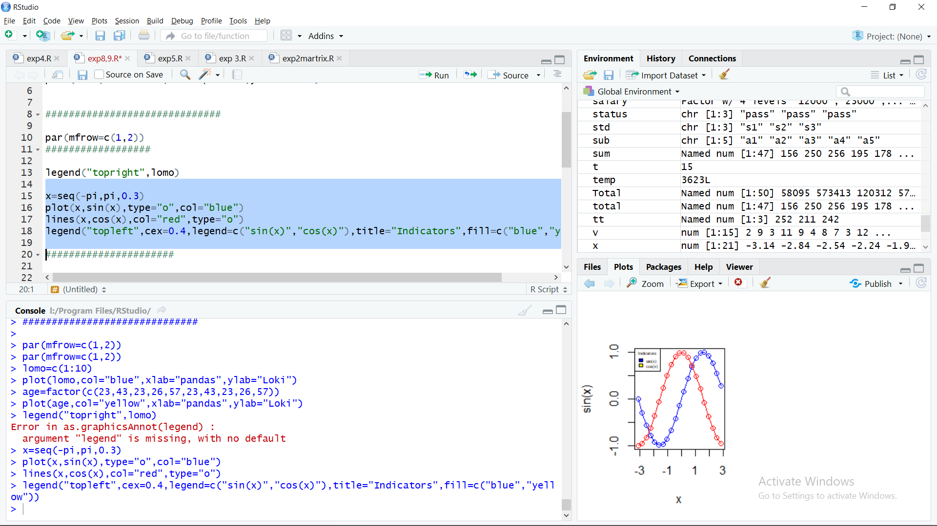

######################

barplot(lomo,col="blue",xlab="x",ylab='Y',main="CARS",

border="red",

density = c(11,11,11,11,11))

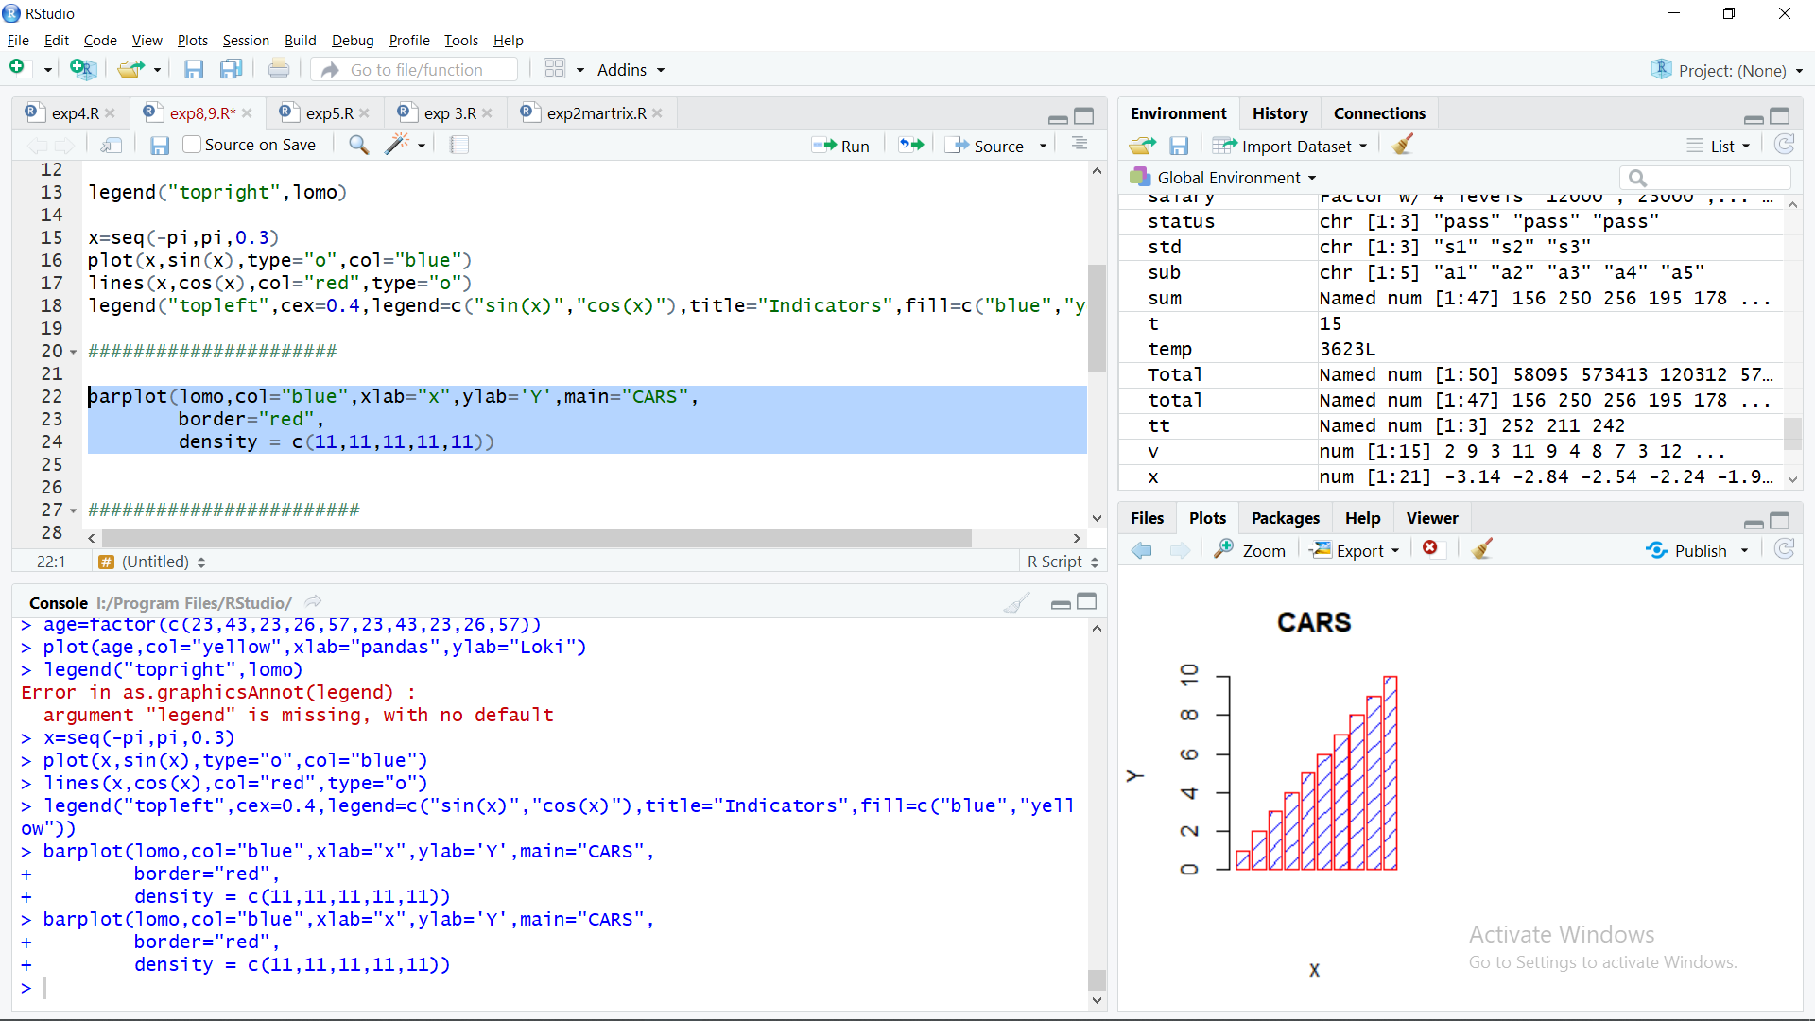

########################

colors = c("green","orange","brown","yellow","red")

months = c("Mar","Apr","May","Jun","Jul")

v=c(2,9,3,11,9,4,8,7,3,12,5,2,8,10,11)

M= matrix(v, nrow = 5, ncol = 5)

barplot(M,names.arg = months,beside=TRUE, xlab = "month", ylab = "cost", col = colors)

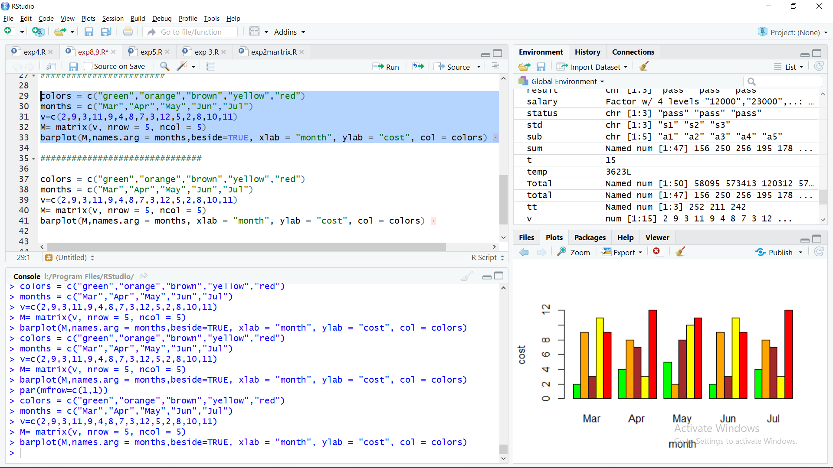

###############################

colors = c("green","orange","brown","yellow","red")

months = c("Mar","Apr","May","Jun","Jul")

v=c(2,9,3,11,9,4,8,7,3,12,5,2,8,10,11)

M= matrix(v, nrow = 5, ncol = 5)

barplot(M,names.arg = months, xlab = "month", ylab = "cost", col = colors)   
